**COMPILE DESIGN SYMBOL TABLE REPORT**

Symbol table is an important data structure created and maintained by compilers in order to store information about the occurrence of various entities such as variable names, function names, objects, classes, interfaces, etc.

Symbol table is used by both the analysis and the synthesis parts of a compiler.

A symbol table is simply a table wh ich can be either linear or a hash table. It maintains an entry for each name.

Variable names and constants

Procedure and function names

Literal constants and strings

Compiler generated temporaries

Labels in source languages

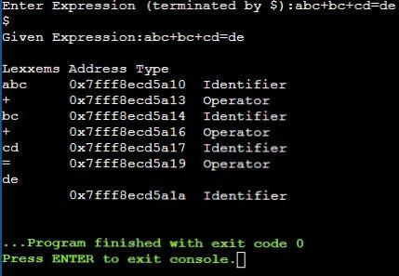Above items are stored in sy mbol table.

In Symbol Table ,

we are taking expressions from user which contain some integers,characters,and some

operators. It will identify characters as identifiers , digits as constants. In the above example X,a,b are identifiers and =,+ are ope rators.